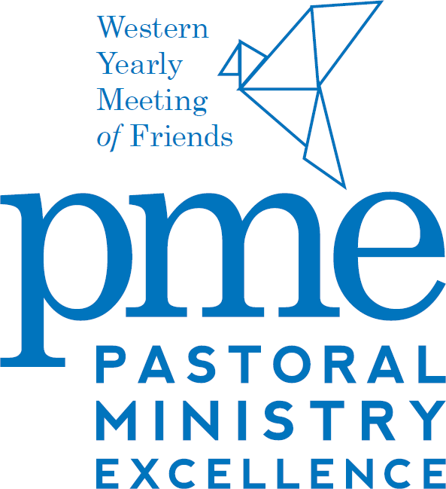

2023 Grants

Purposes of the PME Grant Program
The Western Yearly Meeting Pastoral Ministry Excellence Project (PME) provides an additional layer of economic support and ongoing education for pastoral ministers serving in Western Yearly Meeting. The Pastoral Ministry Excellence Fund has been designated for these purposes:

- Health Care Expense Grants
- Retirement Contribution Grants
- Funding for Annual Pastors Retreat and other financial education opportunities

The PME Project also provides financial information, training, consultation & education for pastors and Meetings.

Eligibility
Pastors, assistant pastors, directors of CE and youth pastors, who serve a WYM Monthly Meeting in paid ministry, but not as volunteers, are eligible if they were serving on January 1, 2023.

Deadline
Complete and submit this application by May 20, 2023.

For information on qualifications, funding, and administration of PME Funds >>>>>>>>>>>>>>>>>>>

Qualifications for Application for PME
Health Care Expense Grants & Retirement Contribution Grants

- Pastors, assistant pastors, directors of CE and youth pastors, who serve a WYM Monthly Meeting in paid ministry, but not as volunteers, are eligible if they were serving on January 1, 2023.
- The pastors must completion of the 2023 WYM Financial Education Opportunity. A list of these opportunities will be provided to Meetings and pastors. Grant funds can be released after approval of the board and upon completion of the 2023 WYM Financial Education Opportunity.
- The Monthly Meeting must complete the written approval from their Monthly Meeting approving the Monthly Meetings’ willingness to
  - allocate the Health Care Expense Grant as outlined by IRS rules for compensation. If the Meeting and pastor elect to place the grant in an HSA, check IRS information regarding the regulations for the HSA which include the pastor having high-deductible health insurance coverage

  - allocate the Retirement Contribution Grant into a pension, retirement, or IRA account for the pastor in accordance with the grant request

  - record in the Monthly Meeting minutes the receipt and disbursement of the grant(s)

  - approve inviting a representative from Western Yearly Meeting visit the Meeting to talk about stewardship and pastoral support.

- Complete and submit this application by May 20, 2023.
Funding
PME Grants are funded by Western Yearly Meeting through the Board on Christian Ministries and Evangelism. The source of the funding is the income from the Bone Ministry and Leadership Fund along with the Pastoral Ministry Excellence (PME) Fund which was raised by efforts of the WYM Pastoral Ministry Excellence Sustainability Task Group through the generosity of Western YM Friends.

Administration
Review and approval of grant requests for health care and retirement contributions are the responsibility of the WYM Board on Christian Ministry & Evangelism. Grant requests need to be submitted to the Yearly Meeting Office by the due date.

