Western Work  FALL, 2019 | Administrative Council  Saturday  November 16, 2019  PLAINFIELD FRIENDS  9:30 a.m.  Coffee & Breakfast Snacks  10:00 a.m.  Devotions  10:30 a.m.  Business Meeting  12 noon  Lunch  Plainfield Friends will provide lunch with a basket put out for donations to help offset the lunch expenses.  1:00 p.m.  Afternoon Program  TBA  INSIDE THIS ISSUE  Outgoing Epistle 2-5  Thank you Wanda 6  Youth 7  Connecting with Meetings 8  Pastors Fall Gathering 9  West Union 9  Upcoming Events 10
“LIFE-GIVING”: giving or having power to give life and spirit : INVIGORATING

There are so many stories in our Yearly Meeting that are
“Life-Giving” stories!
You know….those “little things” that happen among friends that communicate care and love, and those little things that mean that “we” are still alive?
Maybe it’s just a small something that happened and when you stop to think about it, you found it to be “life-giving.”
Friends, we are very much still alive! And the chal- lenge is in our willingness to look for those stories and then share those stories.
We, the SUPT. TEAM, want to invite you to share those stories with us; and we would like to include those stories in Western Work. You are invited to write a short, 50
-100 words article, and send it to us for the next Western Work. And you are more than welcome to send pictures! The deadline for the next Western Work is October 30,
2019.

⇒ The 2019 WYM OUTREACH PROJECT UPDATE:
So far, donations for Girl Child Education in Turkana and Samburu amount to $3,026. Our goal is $15,000.

⇒ Plainfield welcomes their new pastor Cathy Harris.
Welcome back to WYM Cathy!

Continued on page 8

WESTERN YEARLY MEETING

OUTGOING EPISTLE

July 28, 2019
Greetings To Friends Every- where:
Western Yearly Meeting gath- ered in Plainfield, Indiana from July 25-28, 2019 for our 162nd annual session. Each year our Program Committee works with individuals, meet-

UNLEASH THE LOVE,
RELEASE THE POWER

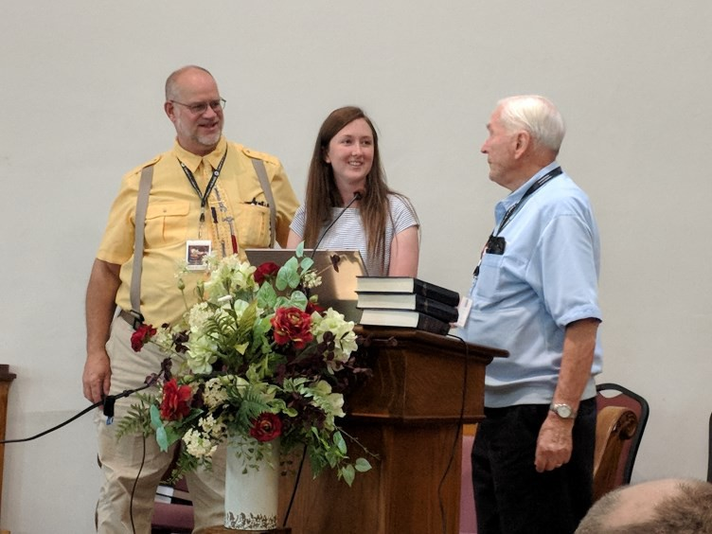
ings, boards,
and committees to help promote Quaker unity in refreshing and helpful ways.
This year was no exception!
Through period- ic email updates, the projected content of this year’s meeting was conveyed in a way to en- courage attendance and inter- est. The theme, “Unleash the Love, Release the Power” was emphasized through daily worship, business sessions, social times, and creative workshops. “For the Spirit God gave us does not make us timid, but gives us power,
love, and self-discipline. (II
Timothy 1:7)” became the ba- sis for each day’s program- ming.
Following an uplifting mini concert by Tom Roberts, Joe Roberts, and Joe Wiegand, Quaker Lecturer, Kelly Kel- lum, General Secretary of
Friends United Meeting, pre- sented how the people of FUM have responded, are responding,
and will continue to respond with God’s Love and Power to the Great Commission on be- half of each one of us who are members. He reminded us of the difficult situations that are sometimes faced by Quakers and how their response helps spread Quaker values in a very real and personal way. Ron Bryan, retired pastor, William Penn professor, and Iowa Yearly Meeting Superinten- dent, was intrigued with our theme. Coming from Grin-
nell, Iowa to be the Daily De- votional Speaker, he made sure each day started on a positive note by helping us
recognize the Love and Power of God working in each of us.

Tom Bertrand came from Virginia to present the report from Friends Com- mittee on National Legislation (FCNL) and continued to share his expertise by leading a luncheon discussion group and presenting an interest group on
Spirit-led Activism. His continued pres- ence and participation through-out the four days provided opportunities for sharing of perspectives and experiences. Western Yearly Meeting remains active- ly involved with FCNL and other affili- ated bodies, relying on their representa- tives to suggest ways we can work be- yond ourselves in the world at large.
Reports from FUM (Kelly Kellum/John Muhanji ); RSWR (Beth Hendricks);
IFCL (Diana Hadley); AFSC (Abdullah Olsen); Earlham College (Kelly Burk/ Anne Houtman); Earlham School of Re- ligion (Dean Matt Hisrich/Prof. Phil Baisley); FWCC (Luanne Hagee); FDS (Lane Sims); QHC (Brandon Dennis); and FAH (Kathy Clendening) were well received and appreciated.

Afternoon workshops designed for all attenders included: a look at “What’s going on in East Africa” presented by
missionaries Shawn and Katrina McCo- naughey; “Modern Psalms in Search of Peace and Justice,” presented by Dwight Wilson; and a panel discussion on “What in Quaker History Needs Our Contemporary Power?” (John Connell, David Kinsey, Bob Henry, and Dan Lee, moderated by Diana Hadley.)
A full program of additional special in- terest workshops allowed members to work in small groups to explore multi- ple ways to “Unleash the Power” in tan- gible ways. The wide ranging topics in- cluded: “Connecting Quakers In the So- cial Media Age,” (MD&N Board);
“Seeking Common Ground with Other Friends for Spirit-led Activism,” (Tom Bertrand); “Unleash the Power and
Love of your Pastor,” (Della Stanley- Green); “Confessions of a Quaker Edu- cator,” (Dr. Alva ‘Doc’ Sibbitt, Jr.); ”Mesquakie Mission Invites You,” (Mac and Bernie McDonald); “Hate Crimes Legislation,” (Rep. Greg Steuerwald); “Bi-Vocational Ministry,” (ESR Prof.
Phil Baisley); “What Can We Do with This Old Building,” (Gene Carter); and
“Meeting Needs in our Local Communi- ty,” (facilitated by Sheri Bonham.)
James Lyon spoke on the topic “Mark and Twain”
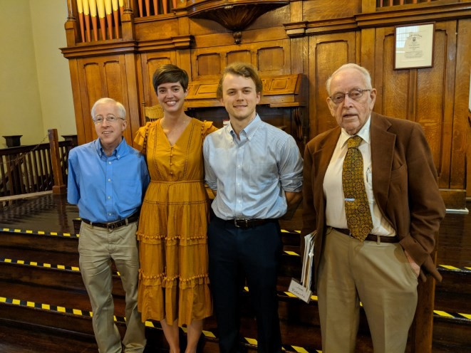
at the special dinner for Ministers
and their Ma- tes on Friday evening.

The annual Memorial Service conducted by Marilynn Bell and Chris Wynn en- couraged us to remember those from Western Yearly Meeting who were wel- comed into heaven during this past year: rejoicing in the legacy of service that they provided and remembering their encouragement during our own growth. Recognizing how, by

EPIISTLE, CONTINUED
“Unleashing the Love,” they are enabling us to “Release the
Power” will allow their legacies to continue in Western Yearly Meeting.

Missions work has always been important to Western Yearly Meeting. Nikki Holland, Direc- tor of FUM Ministries in Belize

UNLEASH THE LOVE,

lowing the Quaker Lecture. Quaker Men provided a Pan- cake Breakfast on Saturday, collecting free-will offerings to help fund Belize School scholar- ships. In 1969 WYM recog-
nized a need to serve our local community, particularly retir- ees who needed safe, modern, affordable housing. As a result,
Friends Apartment Homes
(FAH) was es- tablished and
has served as an

RELEASE THE POWER
ongoing minis-
try ever since. We rejoiced as

was the key speaker prior to the
annual USFW/Quaker Ladies and Quaker Men banquets.
Time was provided during the business sessions for a presen- tation by Betty Heshelman re- garding her recent trip to
Ramallah, Palestine. The Out- reach Board encourages sup- port of the FUM Girl Child Edu- cation Program as a special
project for 2019, with a goal of
$15,000.
USFW provided materials, space, time, and instructions for people to help construct sanitary supplies for ladies in developing countries.
Mesquakie directors, Mac and Bernie McDonald, assisted with the Campfire Conversations fol-
they celebrated their 50 years of continuing service with an open house and reception. Youth
and children are a vital part of Western Yearly Meeting. Quak- er Haven camping experiences, as well as the Board for Peace and Social Concern providing contemporary books with a Quaker
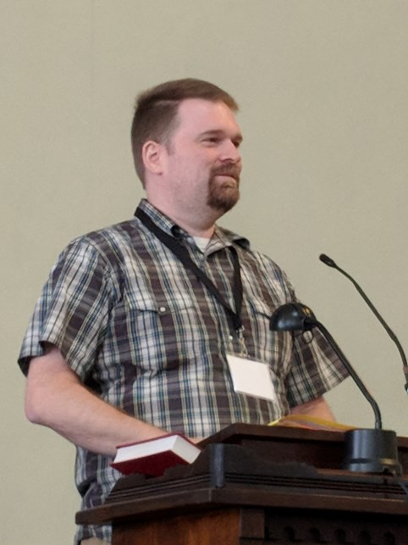
message for use during camp Qui- et Times, are help- ing to pre- pare the younger members
for active roles in leadership

EPIISTLE, CONTINUED
and service. Youth present report to the Gathered Body, summarizing their ac- tivities of the past year and during their own Young Friends Western Yearly Meeting. Throughout the year, WYM
provides funding and other supports to allow students to participate in a variety of opportunities for learning and ser- vice. Quaker Haven Camp continues to work with WYM to provide wholesome camping experience for youth, families, and meeting retreats.

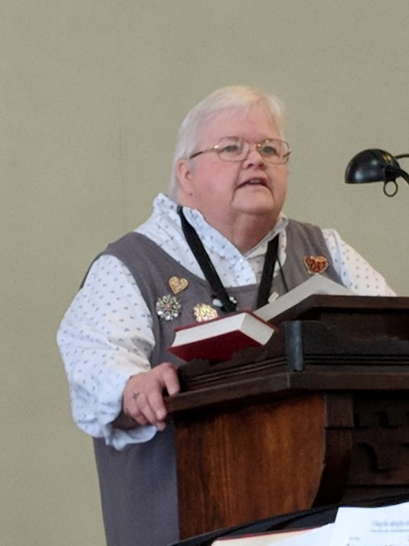
Meeting for Business is a critical part of this annual gathering. Western Yearly Meeting wants to encourage tangible efforts to release the power of Christ in today’s local cultures, recognizing that this may mean shifts from some of the sentimental and historical past ways of doing things. We understand the need to maintain the theological distinctives and preserve those understandings which are distinctly Quaker while find- ing a way forward in today’s world. This requires a willingness to
discuss and act on difficult issues with Christ empow- ered guidance. Please hold us in the Light as we ex- amine these issues.

A reception was held on Sunday to honor Wanda Coffin Baker and show our
appreciation for the work she has done

in WYM as Superintendent. With her move into retirement, it was decided that a three-person team would provide interim support during the revisioning
and transitioning process. Della Stanley
-Green, Sue Whitesel, and Sylvia Graves
will work together to insure cohesive-
ness as we wrestle with our mission and what that will look like going forward.
This will allow an incoming superinten- dent, when found, to have a clearer pic- ture of the vision of Western Yearly Meeting and how they can best support that vision.

We continue to examine the need for ongoing support of individual members of meetings which have been laid down, those who are living in distant locations, and those whose meetings have decided to join other Yearly Meetings. This is- sue is not one with an easy and equita- ble solution. Pray with us that wisdom and discernment will help us meet the
very real needs of these individuals for
continued fellowship and service with Western Year- ly Meeting.

Your continued prayers of support and encourage- ment are appreciated as those in Western Yearly Meeting “Unleash the
Love, Release the Power!”

A reception was held on Sunday to honor Wanda Coffin Baker and show our appreciation for the work she has been doing in WYM since 2012 as Super- intendent.
THANK YOU, Wanda, for serving with your gifts and talents; and for challenging us to take time to stop and listen to each other; to hear God’s calling, and listen for things we have never heard.
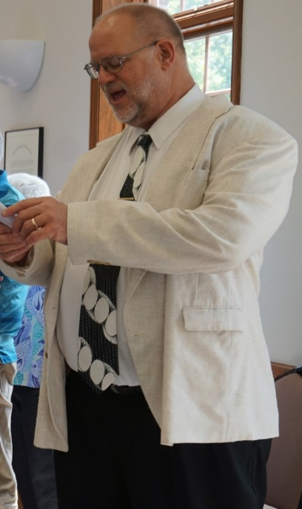
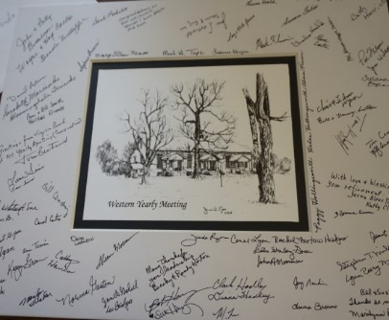
Blessings from all of us, to you, as you begin this new chapter in your life.

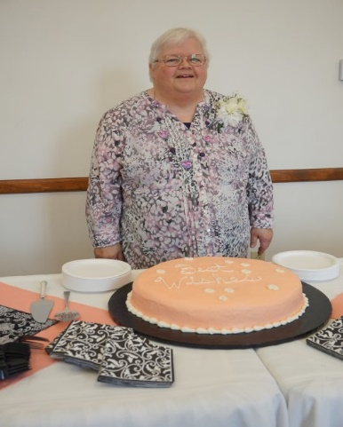
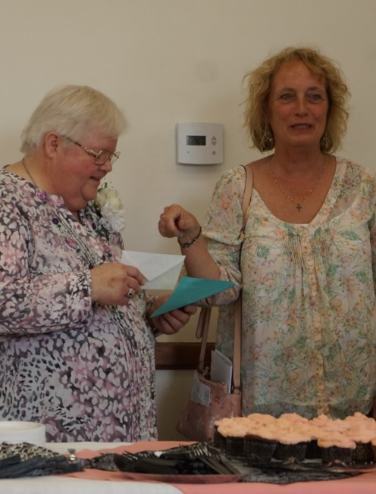
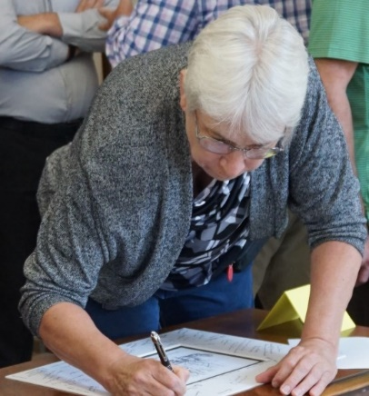
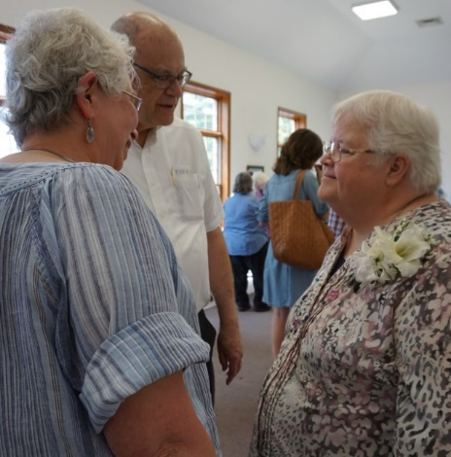
Dear Western Yearly Meeting:
Thank you for the check you gave me. I thought I might use it to go to the
Bahamas to rest. I’m having second
thoughts.
I haven’t yet reached the “rest” part of retirement. No rocker on the deck. No bon-bons or tootsie rolls. But some time to reflect on what we did while I was superintendent. I always amazed while I visited around differ- ent Meetings of the breadth of your talents and the depth of your spiritual life. What gifts you have! Thank you for sharing them with me.
God bless you. Wanda
A note from Wanda….

In Appreciation
I am deeply humbled by the gener- osity of everyone at my retirement. The gifts received are greatly appre- ciated and words of encouragement were very heartwarming.
Thank you and God Bless!

The YOUTH Corner Matthew Klausmeier
Christian Education Director

"The Yearly Meeting youth had a small group but suc- cessful Sessions! Our Sundesmos interns took care of our two high school aged youth, while Hannah Lyon cared for our two elementary aged youth. The interns planned and delivered Bible lessons during the morning activities, and then escorted them to many fun activities after lunch, such as geocaching, the water park, and
board games at a local game store. The youth prepared and served lunch on Saturday, and were quick to jump in and help anytime tables or displays needed to be set up or taken down."
cedirector@mattklausmeier.com 317-801-0450

Office Hours: M-T-W 9 a.m.—3 p.m.

UNLEASH THE LOVE, RELEASE THE POWER

SUMMER CAMP
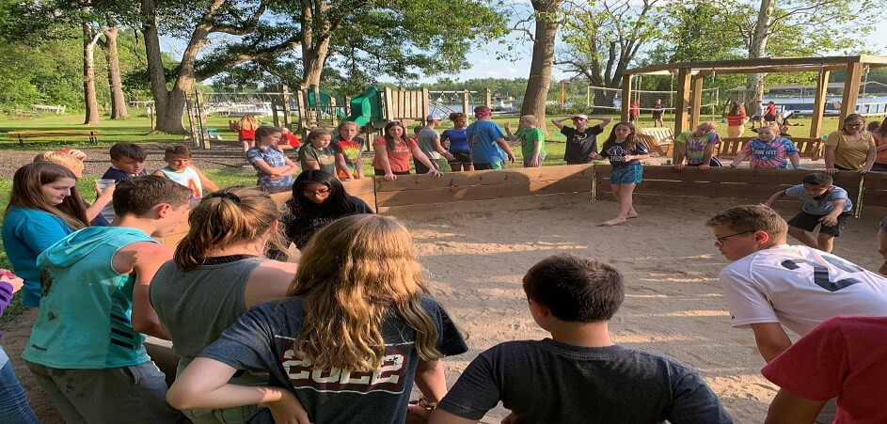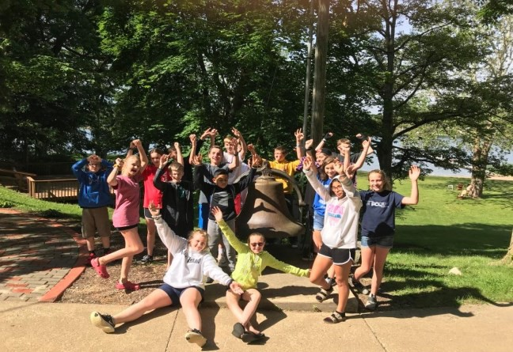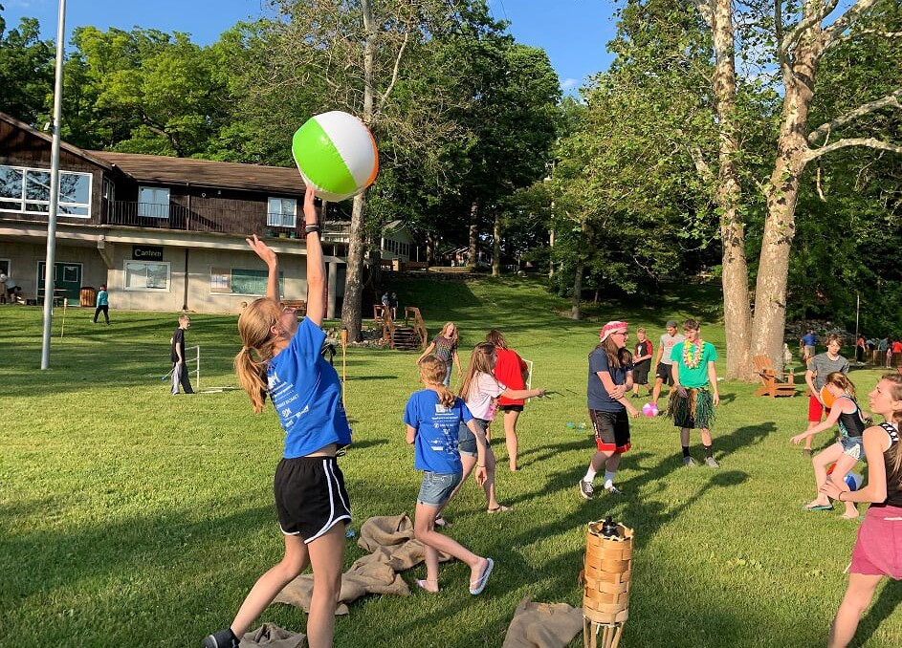
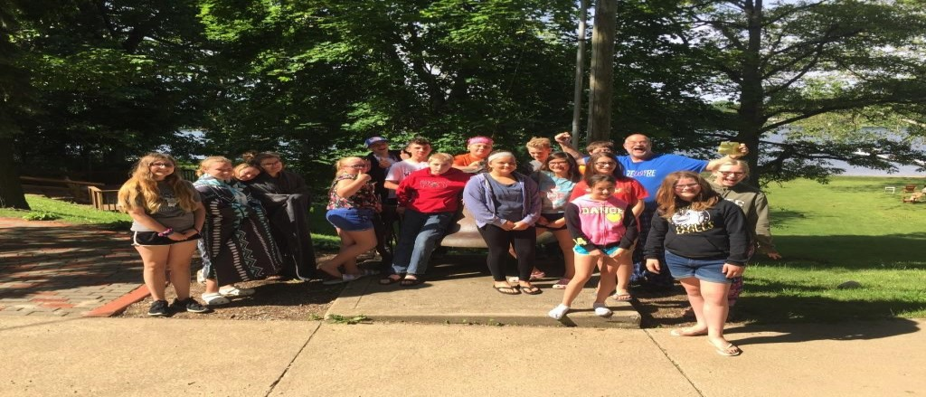
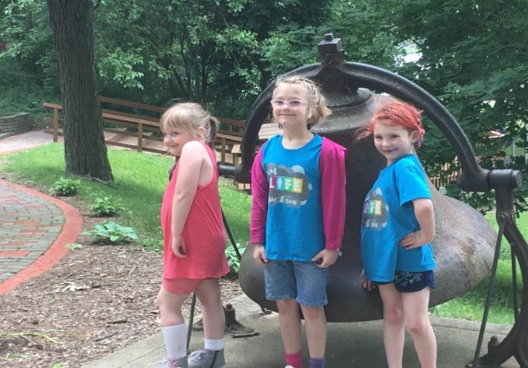
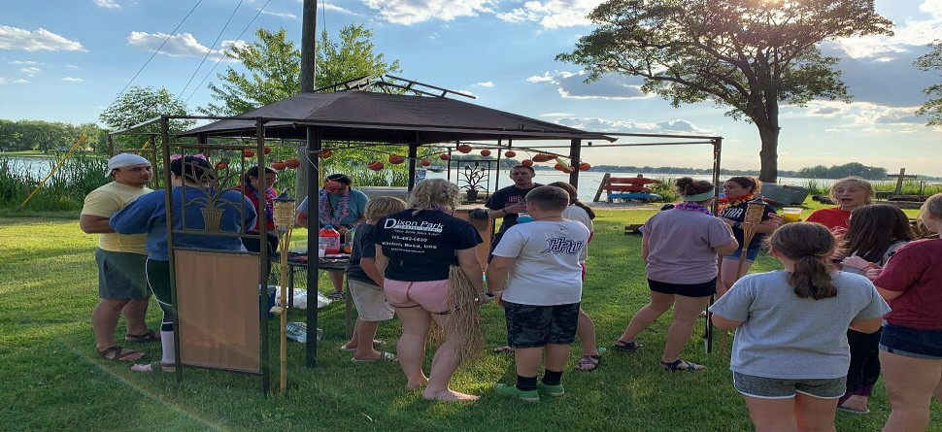

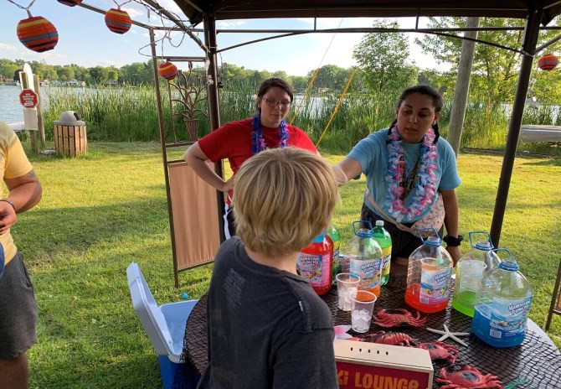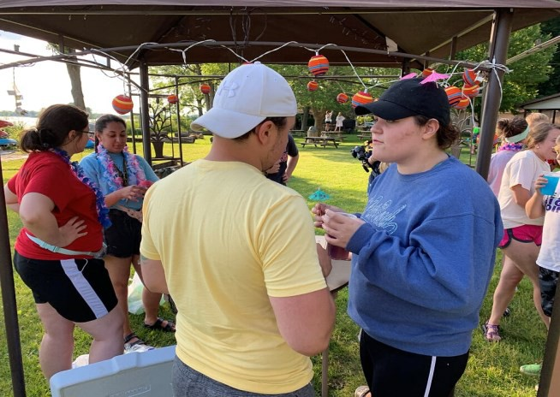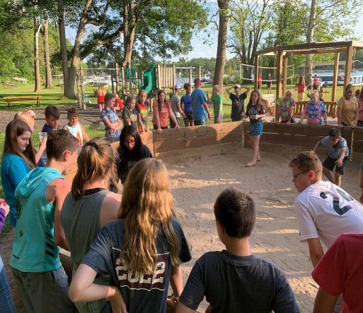

Responsibilities for Connecting with Meetings
Each meeting needs a “go-to” person. Each Supt. Sister has to have a manageable visitation list. Here is the list of our connecting links.

SYLVIA GRAVES
317-442-1361
sylviagraves@gmail.com
57th Street Beech Grove Bloomingdale Blue River Carmel Coloma
Downers Grove Evansville
Fairfield
Farmers Institute Gray

LIFE-GIVING, continued
from page 1
⇒ The fourth graders at
Hadley Friends had an opportunity to put togeth- er their budget during one of their Monthly Meeting for Business sessions.
⇒ Noblesville Friends now has four generations in a family that are now members of their Meet- ing!
⇒ West Newton shares their building with Camby Tabernacle, a Pentecost congregation of about 35 people.

SUE WHITESEL
317-840-5021
stwhitesel@sbcglobal.net
Newport Newberry
Noblesville First Friends
Paoli
Plainfield Russiaville
Sandreek-Azalia Shiloh
Tangier Valley Mills West Newton West Union

DELLA STANLEY-GREEN
317-313-1599
dellasgwym@gmail.com
Hadley Hazel Dell Hopewell
Indianapolis First Friends
Kokomo Fist Friends Lick Creek
Marshall Federated Mooresville
New London New Salem Newport Second Friends West Middleton
WYM PASTORS
FALL GATHERING
For: pastors/spouses; retired pastors/spouses; recording candidates/spouses
This event is funded by the Pastoral Ministry Excellence Program, so there is no cost to you.

Saturday November 9, 2019
Carmel Friends ~ 651 W. Main Street ~ Carmel IN ~ 46032
3:00 p.m.—6:00 p.m. ~ A catered meal at 5:00 p.m.

Special Guest: Bill Kincaid
Christian Theology Seminary Professor and past Interim Dean of the Seminary

LIVING
IN TRANSITION

RSVP by Friday November 1 to Sue Whitesel 317-840-5021 ~ stwhitesel@sbcglobal.net
or

West Union Friends Meeting Historical Marker Dedication
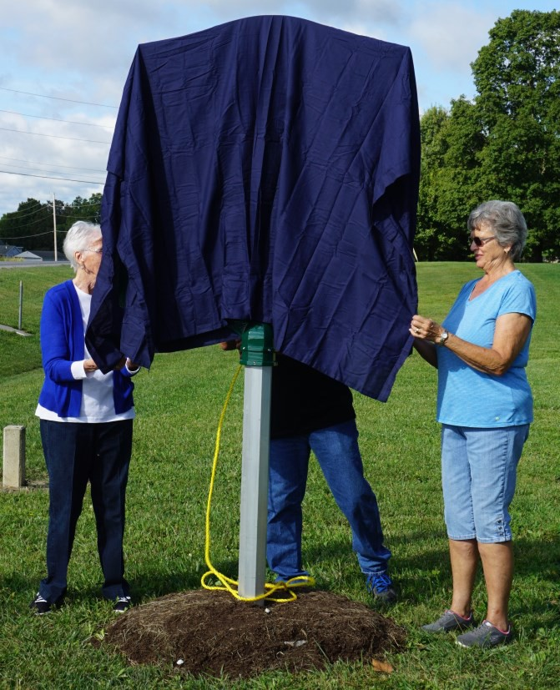
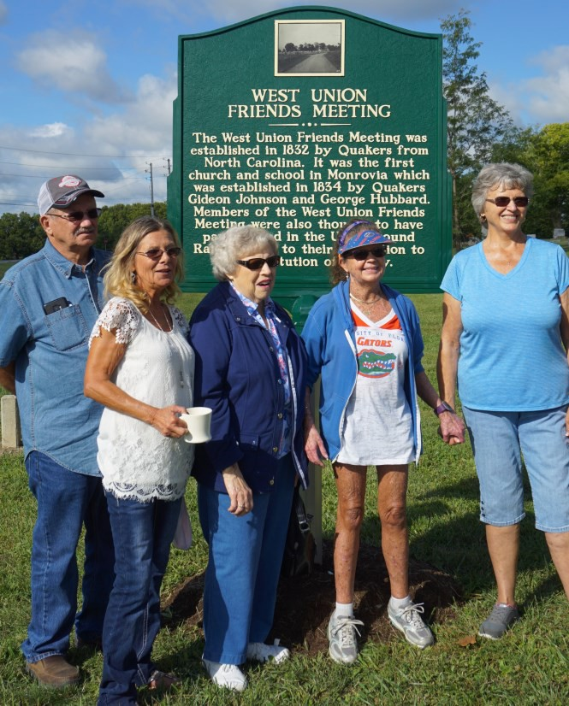
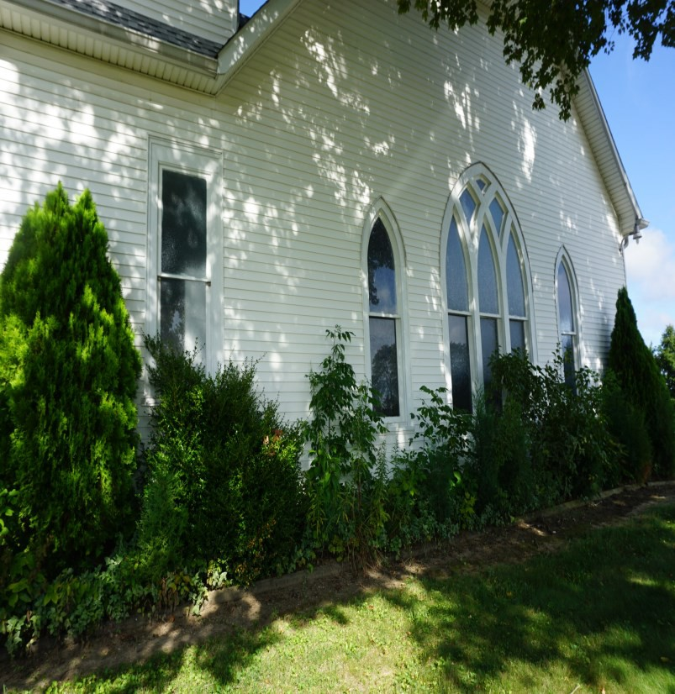

The Monrovia His- torical Society and the Alumni Association ap- proached west Union Friends several months ago and presented them with an idea of putting a historical marker on their grounds. So on Saturday September 7, 2019, friends and families gathered at West Union to dedicate this historical marker.
This dedication was a part of the yearly festival that Monrovia has each year.
Guest speakers in- cluded Steve Reeder,
Randy Marsh, and Senator
Rodrick Bray. Holly Satter- ly, 6th generation West Un- ion Member and Martha Fisher, long-time member unveiled the marker. Pic- ture one: Martha Fisher;
Holly Satterly. Picture two: Jim Satterly; Jodi Illg; Barb Everett; Ronna Lee; Holly Satterly; all members and attenders of West Union.

The historical
marker says this:

The West Union Friends Meeting was established in 1832 by Quakers from North Carolina. It was the first church and school in Mon- rovia which was established in 1834 by Quakers Gideon Johnson and George Hub- bard. Members of the West Union Friends Meeting were also thought to have partici- pated in the Underground Railroad due to their oppo- sition to the institution of slavery.
—Text written by Wyatt Har- vey
Guests enjoyed won- dering around the grounds, walking through the ceme- tery, and then were invited inside the church for re- freshments and conversa- tions.

UNLEASH THE LOVE, RELEASE THE POWER

WESTERN WORK
PRSRT STD
U.S. POSTAGAE PAID PLAINFIELD,IN PERMIT NO 86
Western Yearly Meeting 203 S. East Street
P.O. Box 70
Plainfield, IN 46168
Phone: 317-839-2789
Toll Free: 1-800-909-3452

OFFICE HOURS
9 a.m. –12 noon
1 p.m.—3 p.m.
Della
Monday/Tuesday/Wednesday
Sylvia—Thursday Sue- Friday
Always subject to change, these are
the days the Supt. Sisters will in in the office.

STAFF
INTERIM CO-SUPERINTENDENTS

Della Stanley-Green
Team Leader
dellasgwym@gmail.com
317-313-1599

Sylvia Graves
sylviamillsgraves@gmail.com 317-442-1361

Sue Whitesel
stwhitesel@sbcglobal.net 317-840-5021

————————————–———--———-
Matthew Klausmeier
Christian Education Director cedirector@mattklausmeier.com 317-801-0450
Office Hours: M-T-W: 9 a.m.—3 p.m.

————————————————————
Bonnie Sims
Administrative Assistant westernym@sbcglobal.net
Office Hours: M—F: 9 a.m.—3 p.m.

———————————————————
Sarah Lookabill Yearly Meeting Clerk slookabill@att.net 317-431-6342

Tuesday, September 24, 2019
USFW Fall Conference
Kokomo Cross America, 840 Daniel Drive
Registration is due by September 18 to
Peggy Hollingsworth, hollypeg@hotmail.com
Saturday, October 19, 2019 Executive Committee Meeting
Plainfield
Sunday, October 20, 2019 Ice Cream Social and Area Meeting
Russiaville Friends
5:00 p.m. Meal
6:00 p.m. Program Presentation
Saturday, October 26, 2019 Quaker Market
Mooresville Friends
9:00 a.m.—2:00 p.m.
Saturday, November 2, 2019 Faith & Practice Interactive Workshop
West Newton
8:30 a.m.—2:30 p.m.
Sunday, November 3, 2019 West Central Area Meeting
Valley Mills

